Lesson 5 Demo 4: Running a Container vs. Running a Service

This section will guide you to:

* Run a container from an image
* Run the image as a replicated service

**Step 1:** Check whether all the nodes in the swarm cluster are in Ready state

*sudo docker node ls*

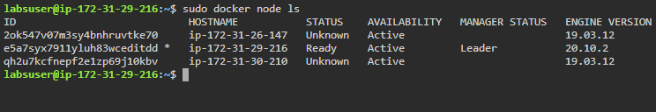

**Step 2:** Pull the latest version of *nginx* image from Docker Hub

*sudo docker pull nginx:latest*

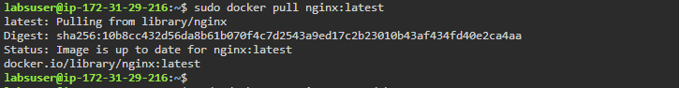

**Step 3:** Run a container from the *nginx* image

*sudo docker container run -d *

*--name nginx-container nginx:latest*

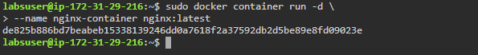

**Step 4:** List all the running containers to check the newly created *nginx* container

*sudo docker ps*

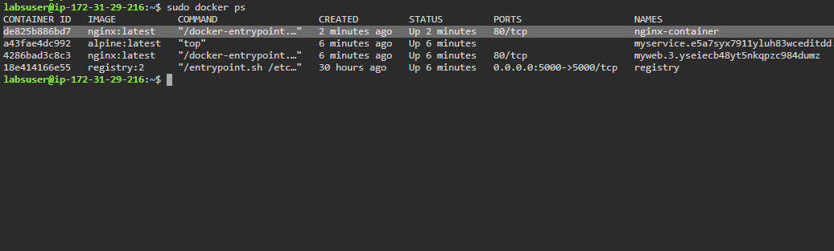

**Step 5:** Run the *nginx* image as a service

*sudo docker service create *

*--name nginx-service *

*--replicas 4 nginx:latest*

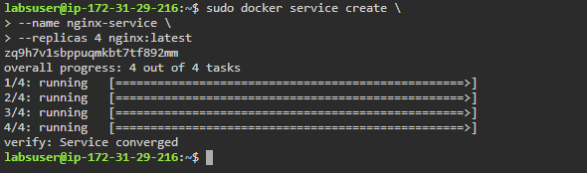

**Step 6:** List all the services running in the swarm cluster

*sudo docker service ls*

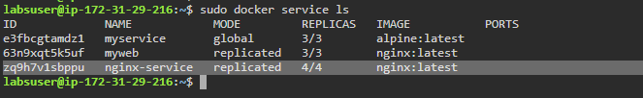

**Step 7:** List all the tasks of the *nginx-service*

*sudo docker service ps nginx-service*

